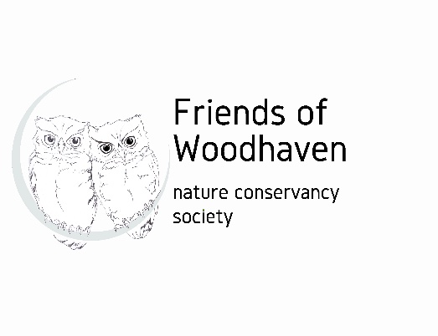
DONATION FORM
Friends of Woodhaven Nature Conservancy is a not-for-profit society to protect and improve the overall well-being of Woodhaven Nature Conservancy for the benefit of the public and future generations. Our aim is to do this by promoting education about the park and by hosting or facilitating free public events regarding conservation of the park’s ecosystem, the history, and culture of Woodhaven, and the plant and animal life found within the park.

Donation: Click or tap here to enter text. (Amounts over $10 will receive tax receipt)
☐I am a member of Friends of Woodhaven Nature Conservancy Society

Date: Click or tap here to enter text.

Your Name: Click or tap here to enter text.

If this donation is being made on behalf of or in memory of someone, please note the name here: Click or tap here to enter text.

Your Email address: Click or tap here to enter text.

Your Mailing Address: Click or tap here to enter text.

Your Phone Number:Click or tap here to enter text.

Indicate How You Are Submitting Funds (note: Payable in Canadian funds)
☐I will mail this form and cheque payable to Friends of Woodhaven Nature Conservancy to Friends of Woodhaven Nature Conservancy, 1112 Hammer Court, Kelowna BC, V1W 2B9, Canada
☐I will e-transfer funds to info@friendsofwoodhaven.ca AND email this form to the same address.

For information about FWNC, see the website: https://www.friendsofwoodhaven.ca/ . Also on Facebook: https://www.facebook.com/friendsofwoodhaven/

