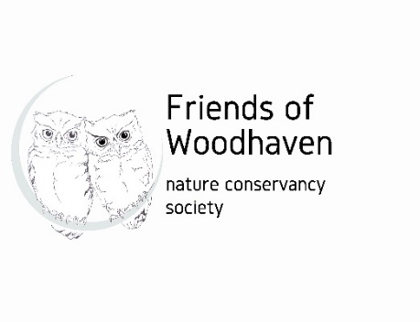
MEMBERSHIP FORM
Friends of Woodhaven Nature Conservancy is a not-for-profit society to protect and improve the overall well-being of Woodhaven Nature Conservancy for the benefit of the public and future generations. Our aim is to do this by promoting education about the park and by hosting or facilitating free public events regarding conservation of the park’s ecosystem, the history, and culture of Woodhaven, and the plant and animal life found within the park.
Check All Applicable Boxes:
☐One Year Membership, Individual $10

☐One Year Membership, Family $15

☐This is a renewal

☐Donation: Click or tap here to enter text.(Amounts over $10 will receive tax receipt)
TOTAL:Click or tap here to enter text.

Fill in the Membership Information:

Date: Click or tap here to enter text.

Individual Name: Click or tap here to enter text.

Family Member Names: Click or tap here to enter text.

Email address:Click or tap here to enter text.

Mailing Address: Click or tap here to enter text.
Phone Number:Click or tap here to enter text.
Submit Form and Funds:
Mail this form and cheque payable to Friends of Woodhaven Nature Conservancy to : Friends of Woodhaven Nature Conservancy, 1112 Hammer Court, Kelowna BC, V1W 2B9, Canada
OR etransfer funds to info@friendsofwoodhaven.ca and email this form to the same address.
Payable in Canadian funds.
For information about FWNC, see the website: https://www.friendsofwoodhaven.ca/ Also on Facebook: https://www.facebook.com/friendsofwoodhaven/

